E Contents

for

Data Communication

CHAPTER 1

LEARNING OUTCOMES
After undergoing the topic, the students will be able to understand:
- How data transfers from one place to another
- Concept of analog and digital communication
- Concept of multiplexing
- Guided and unguided media

INTRODUCTION
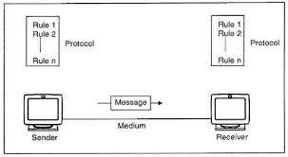
Data communications (DC) is the process of using computing and communication technologies to transfer data from one place to another, and vice versa. It enables the movement of electronic or digital data between two or more nodes, regardless of geographical location, technological medium or data contents.

Transmission Modes
Transmission mode refers to the mechanism of transferring of data between two devices connected over a network. It is also called Communication Mode. These modes direct the direction of flow of information. There are three types of transmission modes. They are:

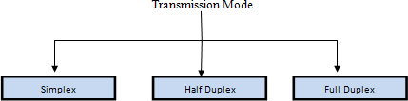

SIMPLEX MODE
In this type of transmission mode, data can be sent only in one direction i.e. communication is unidirectional.

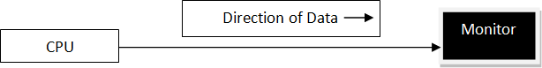

HALF DUPLEX MODE
Half-duplex data transmission means that data can be transmitted in both directions on a signal carrier, but not at the same time.
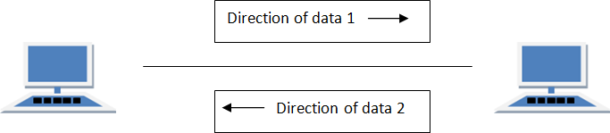

FULL DUPLEX Mode
In full duplex system we can send data in both the directions as it is bidirectional at the same time in other words, data can be sent in both directions simultaneously.
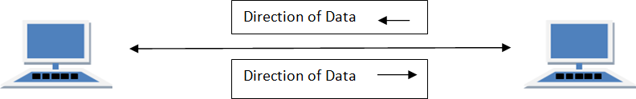

COMPONENTS OF DATA COMMUNICATION

Message
The message is the data or information to be communicated. It may consist of text, number, pictures, sound, video or any a combination of these.
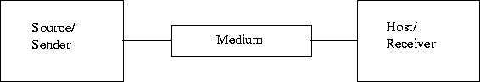

Sender

Sender is a device that sends message. The message can consist of text, numbers, pictures etc. it is also called source or transmitter. Normally, computer is use as sender in information communication systems.

Receiver
Receiver is a device that receives message. It is also called sink. The receiver can be computer, printer or another computer related device. The receiver must be capable of accepting the message.

Medium
Medium is the physical path that connects sender and receiver. It is used to transmit data. The medium can be a copper wire, a fiber optic cable, microwaves etc. it is also called communication channel.

Software
Software is used to provide remote access to systems and exchange files and messages in text, audio and/or video formats between different computers or users.

Types of computer networks

LAN
A computer network spanned inside a building and operated under single administrative system is generally termed as Local Area Network (LAN). Usually, LAN covers an organization offices, schools, colleges or universities. Number of systems connected in LAN may vary from as least as two to as much as 16 million. LAN provides a useful way of sharing the resources between end users. The resources such as printers, file servers, scanners, and internet are easily sharable among computers.
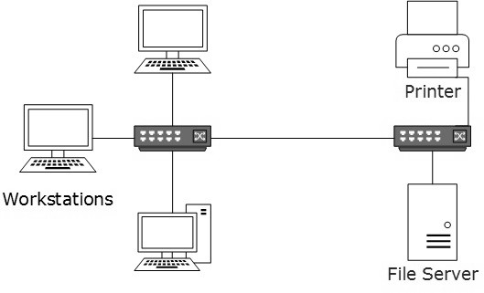

LANs are composed of inexpensive networking and routing equipment. It may contain local servers serving file storage and other locally shared applications. It mostly operates on private IP addresses and does not involve heavy routing. LAN works under its own local domain and controlled centrally.
LAN uses either Ethernet or Token-ring technology. Ethernet is most widely employed LAN technology and uses Star topology, while Token-ring is rarely seen.
LAN can be wired, wireless, or in both forms at once.

Metropolitan Area Network(MAN)
The Metropolitan Area Network (MAN) generally expands throughout a city such as cable TV network. It can be in the form of Ethernet, Token-ring, ATM, or Fiber Distributed Data Interface (FDDI).
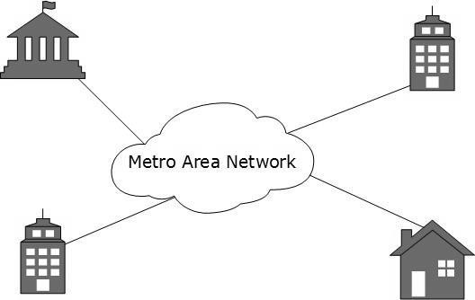
Metro Ethernet is a service which is provided by ISPs. This service enables its users to expand their Local Area Networks. For example, MAN can help anorganization to connect all of its offices in a city.
Backbone of MAN is high-capacity and high-speed fiber optics. MAN works in between Local Area Network and Wide Area Network. MAN provides uplink for LANs to WANs or internet.

Wide Area Network(WAN)
As the name suggests, the Wide Area Network (WAN) covers a wide area which may span across provinces and even a whole country. Generally, telecommunication networks are Wide Area Network. These networks provide connectivity to MANs and LANs. Since they are equipped with very high speed backbone, WANs use very expensive network equipment.
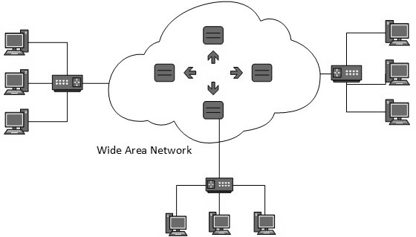

WAN may use advanced technologies such as Asynchronous Transfer Mode (ATM), Frame Relay, and Synchronous Optical Network (SONET). WAN may be managed by multiple administrations.

COMPUTER NETWORK TOPOLOGIES
A Network Topology is the arrangement with which computer systems or network devices are connected to each other. Topologies may define both physical and logical aspect of the network. Both logical and physical topologies could be same or different in a same network.

Point-to-Point
Point-to-point networks contains exactly two hosts such as computer, switches, routers, or servers connected back to back using a single piece of cable. Often, the receiving end of one host is connected to sending end of the other and vice versa.

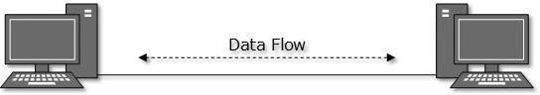
If the hosts are connected point-to-point logically, then may have multiple intermediate devices. But the end hosts are unaware of underlying network and see each other as if they are connected directly.

Bus Topology
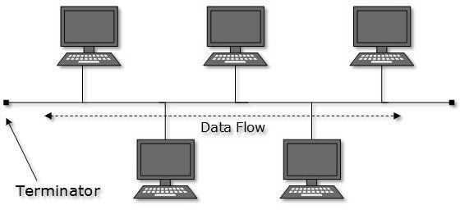
In case of Bus topology, all devices share single communication line or cable. Bus topology may have problem while multiple hosts sending data at the same time. Therefore, Bus topology either uses CSMA/CD technology or recognizes one host as Bus Master to solve the issue. It is one of the simple forms of networking where a failure of a device does not affect the other devices. But failure of the shared communication line can make all other devices stop functioning.

Both ends of the shared channel have line terminator. The data is sent in only one direction and as soon as it reaches the extreme end, the terminator removes the data from the line.

Star Topology
All hosts in Star topology are connected to a central device, known as hub device, using a point-to-point connection. That is, there exists a point to point connection between hosts and hub. The hub device can be any of the following:
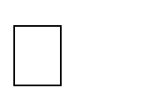
Layer-1 device such as hub or repeater Layer-2 device such as switch or bridge

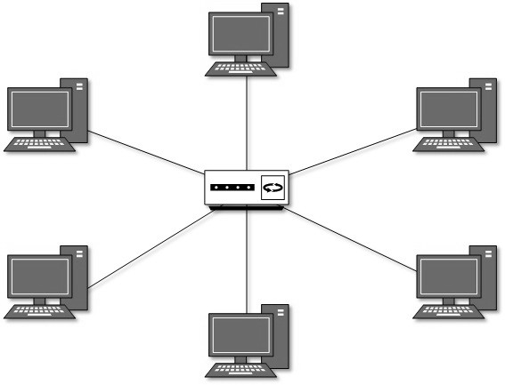
Layer-3 device such as router or gateway

As in Bus topology, hub acts as single point of failure. If hub fails, connectivity of all hosts to all other hosts fails. Every communication between hosts takes place through only the hub. Star topology is not expensive as to connect one more host, only one cable is required and configuration is simple.

Ring Topology
In ring topology, each host machine connects to exactly two other machines, creating a circular network structure. When one host tries to communicate or send message to a host which is not adjacent to it, the data travels through all intermediate hosts. To connect one more host in the existing structure, the administrator may need only one more extra cable.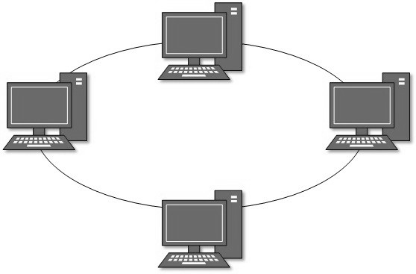

Failure of any host results in failure of the whole ring. Thus, every connection in the ring is a point of failure. There are methods which employ one more backup ring.

Mesh Topology
In this type of topology, a host is connected to one or multiple hosts. This topology has hosts in point-to-point connection with every other host or may also have hosts which are in point-to-point connection with few hosts only.
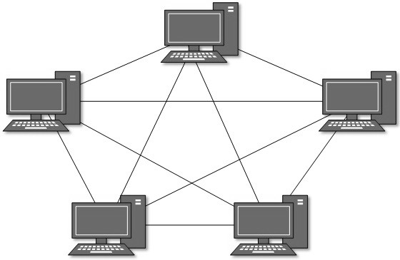

Hosts in Mesh topology also work as relay for other hosts which do not have direct point- to-point links. Mesh technology comes into two types:
Full Mesh: All hosts have a point-to-point connection to every other host in the network. Thus for every new host n(n-1)/2 connections are required. It provides the most reliable network structure among all network topologies.
Partially Mesh: Not all hosts have point-to-point connection to every other host. Hosts connect to each other in some arbitrarily fashion. This topology exists where we need to provide reliability to some hosts out of all.

Tree Topology
Also known as Hierarchical Topology, this is the most common form of network topology in use presently. This topology imitates as extended Star topology and inherits properties of Bus topology.
This topology divides the network into multiple levels/layers of network. Mainly in LANs, a network is bifurcated into three types of network devices. The lowermost is access-layer where computers are attached. The middle layer is known as distribution layer, which works as mediator between upper layer and lower layer.
The highest layer is known as core layer, and is central point of the network, i.e. root of the tree from which all nodes fork.
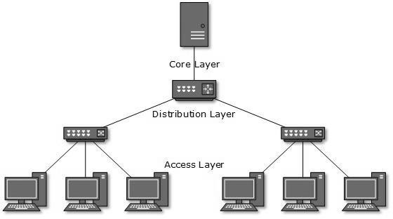

All neighboring hosts have point-to-point connection between them. Similar to the Bus topology, if the root goes down, then the entire network suffers even though it is
not the single point of failure. Every connection serves as point of failure, failing of which divides the network into unreachable segment.

Hybrid Topology
A network structure whose design contains more than one topology is said to be hybrid topology. Hybrid topology inherits merits and demerits of all the incorporating topologies.

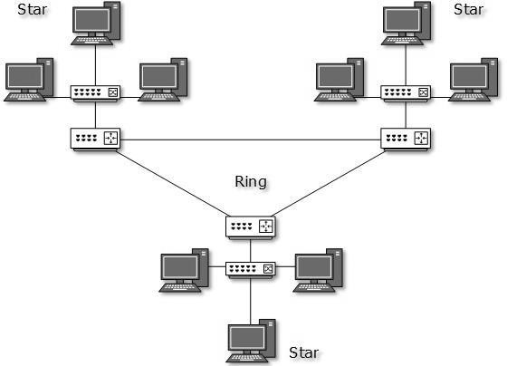

The above picture represents an arbitrarily hybrid topology. The combining topologies may contain attributes of Star, Ring, Bus, and Daisy-chain topologies. Most WANs are connected by means of Dual-Ring topology and networks connected to them are mostly Star topology networks. Internet is the best example of largest Hybrid topology.

CHAPTER 2
- Signals
When data is sent over physical medium, it needs to be first converted into electromagnetic signals. Data itself can be analog such as human voice, or digital such as file on the disk. Both analog and digital data can be represented in digital or analog signals.

Digital Signals
Digital signals are discrete in nature and represent sequence of voltage pulses. Digital signals are used within the circuitry of a computer system.
Time

Analog Signals
Analog signals are in continuous wave form in nature and represented by continuous electromagnetic waves.
Time

Periodic and Non Periodic Signals

The classification of signal is as under table
Signal
Analog Signal
Digital Signal
Non-Periodic
Digital Signal
Periodic
Digital Signal
Non-Periodic
Analog Signal
Periodic
Analog Signal

Periodic Signal and Aperiodic Signal
Periodic Signal : The periodic signals accomplishes a pattern over a certain time interval and continuously repeats the same over a same time.
Aperiodic Signal : The Aperiodic signals accomplishes a pattern over acertain time internal and may differ in pattern in the next interval.
Value

Periodic Analog Signals

These are the continuous signals that accomplishes a pattern over a certain time, known as periodic and then continuously repeats the pattern, known as cycle in the same period as shown in fig.

Value

Time

Periodic Analog Signal

Aperiodic Analog Signal
These are the continuous signal that accomplishes a pattern in a period and then changes the pattern in other interval as shown in fig.

Value

Time

Aperiodic Analog Signal

Periodic Digital Signals
These are the discrete signals that accomplishes a pattern in a period and the represents the same pattern as a cycle in next period. It is different from periodic analog signal in form of discrete nature instead of continuous nature as shown in fig.

Value

Time

Aperiodic Digital Signals
These are the discrete signal that accomplishes a pattern in a period and then changes the other pattern in next period. It differs from aperiodic digital signal in form of its discrete nature instead of continuous natures as shown in fig.

Value

Time

Digital signals represents information at discrete events. It is not continuous signal as it remains stable an a particular level for a particular time interval instead of ranging continuously at every time.
۞A digital signals may have two or more than two levels.
Bit rate : It is the number of bits that can be transmitted from sender to receiver in one second. It’s unit is bits per second (bits/second or bps). The bit rate is different for both sender and the receiver.
Bit Length : It represents the length that a single bit occupies when it is transmitted from sender to receiver through the propagation medium. It wraps the period to the speed with which a bit can be translated from sender to receiver (in form of cycles).
۞Bit length is represented in 2 ways:
Bit length = period ₓ propagation speed
Bit length = propagation speed/frequency (as period =

Thus the bit length depends on factors
Propagation speed : It is the speed with which the data is transmitted from sender to receiver Period frequency : Period is the time to cover a cycle and frequency is inversely proportional to period.

Transmission Impairment
When signals travel through the medium, they tend to deteriorate. This may have many reasons as given:

Attenuation
For the receiver to interpret the data accurately, the signal must be sufficiently strong. When the signal passes through the medium, it tends to get weaker. As it covers distance, it loses strength.

Dispersion
As signal travels through the media, it tends to spread and overlaps. The amount of dispersion depends upon the frequency used.

Delay distortion
Signals are sent over media with pre-defined speed and frequency. If the signal speed and frequency do not match, there are possibilities that signal reaches destination in Data Communication and Computer Network arbitrary fashion. In digital media, this is very critical that some bits reach earlier then the previously sent ones.

Noise
Random disturbance or fluctuation in analog or digital signal is said to be Noise in signal, which may distort the actual information being carried.
It is a unwanted effect that adds to the signal send by the receiver at any place
- At sender side
- At receiver side
- During the transmission through propagation medium.
If the noise had made minor changes to the original signal then it can be negleted and it the whole signal.

Receiver

Sender

  - Propagation Media

+ =

CHAPTER 3
- DIGITAL TRANSMISSION
  - Digital-to-Digital Conversion
This section explains how to convert digital data into digital signals. It can be done in two ways, line coding and block coding. For all communications, line coding is necessary whereas block coding is optional.

Line Coding
The process for converting digital data into digital signal is said to be Line Coding. Digital data is found in binary format. It is represented (stored) internally as series of 1s and 0s.

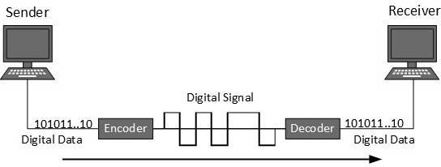
Digital signal is denoted by discreet signal, which represents digital data. There are three types of line coding schemes available

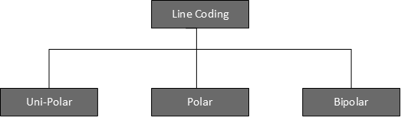

Unipolar Encoding
Unipolar encoding schemes use single voltage level to represent data. In this case, to represent binary 1, high voltage is transmitted and to represent 0, no voltage is transmitted. It is also called Unipolar-Non-return-to-zero, because there is no rest condition i.e. it either represents 1 or 0.
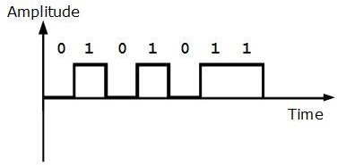
Polar Encoding
Polar encoding scheme uses multiple voltage levels to represent binary values. Polar encodings is available in four types:

Polar Non Return to Zero (Polar NRZ)
It uses two different voltage levels to represent binary values. Generally, positive voltage represents 1 and negative value represents 0. It is also NRZ because there is no rest condition.
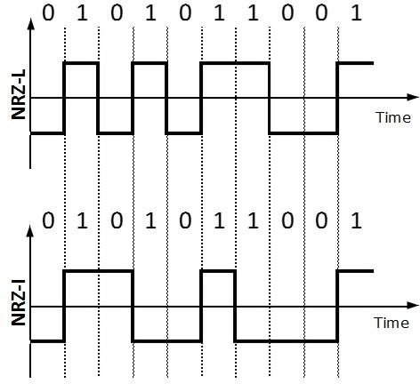
NRZ scheme has two variants: NRZ-L and NRZ-I.

NRZ-L changes voltage level at when a different bit is encountered whereas NRZ-I changes voltage when a 1 is encountered.

Return to Zero (RZ)
Problem with NRZ is that the receiver cannot conclude when a bit ended and when the next bit is started, in case when sender and receiver’s clock are not synchronized.
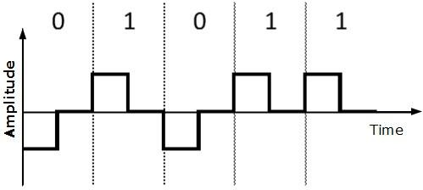

RZ uses three voltage levels, positive voltage to represent 1, negative voltage to represent 0 and zero voltage for none. Signals change during bits not between bits. Manchester
This encoding scheme is a combination of RZ and NRZ-L. Bit time is divided into two halves. It transits in the middle of the bit and changes phase when a different bit is encountered.

Differential Manchester
This encoding scheme is a combination of RZ and NRZ-I. It also transits at the middle of the bit but changes phase only when 1 is encountered.

Bipolar Encoding
Bipolar encoding uses three voltage levels, positive, negative, and zero. Zero voltage represents binary 0 and bit 1 is represented by altering positive and negative voltages.
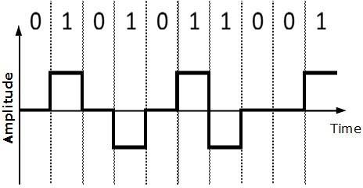

Block Coding
To ensure accuracy of the received data frame, redundant bits are used. For example, in even-parity, one parity bit is added to make the count of 1s in the frame even. This way the original number of bits is increased. It is called Block Coding.
Block coding is represented by slash notation, mB/nB. Means, m-bit block is substituted with n-bit block where n > m. Block coding involves three steps:
- Division
- Substitution
- Combination.

Analog-to-Digital Conversion
Microphones create analog voice and camera creates analog videos, which are treated is analog data. To transmit this analog data over digital signals, we need analog to digital conversion.
Analog data is a continuous stream of data in the wave form whereas digital data is discrete. To convert analog wave into digital data, we use Pulse Code Modulation (PCM).
PCM is one of the most commonly used methods to convert analog data into digital form. It involves three steps:
- Sampling
- Quantization
- Encoding.

Sampling
The analog signal is sampled every T interval. Most important factor in sampling is the rate at which analog signal is sampled. According to Nyquist Theorem, the sampling rate must be at least two times of the highest frequency of the signal.
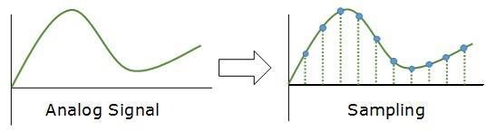

Quantization
Sampling yields discrete form of continuous analog signal. Every discrete pattern shows the amplitude of the analog signal at that instance. The quantization is done between the maximum amplitude value and the minimum amplitude value. Quantization is approximation of the instantaneous analog value.
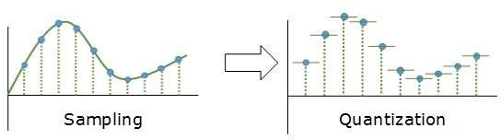

Encoding
In encoding, each approximated value is then converted into binary format.
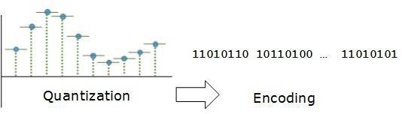

Transmission Modes
The transmission mode decides how data is transmitted between two computers. The binary data in the form of 1s and 0s can be sent in two different modes: Parallel and Serial.

Parallel Transmission
The binary bits are organized into groups of fixed length. Both sender and receiver are connected in parallel with the equal number of data lines. Both computers distinguish between high order and low order data lines. The sender sends all the bits at once on all lines. Because the data lines are equal to the number of bits in a group or data frame, a complete group of bits (data frame) is sent in one go. Advantage of Parallel transmission is high speed and disadvantage is the cost of wires, as it is equal to the number of bits sent in parallel.
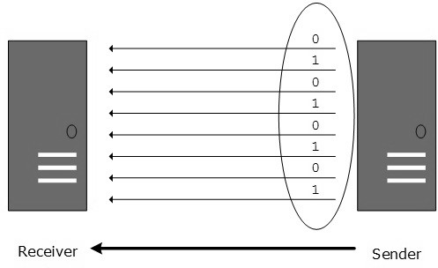

Serial Transmission
In serial transmission, bits are sent one after another in a queue manner. Serial transmission requires only one communication channel.
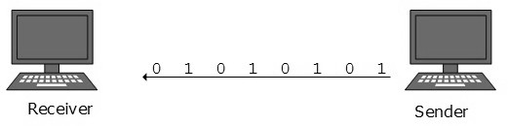
Serial transmission can be either asynchronous or synchronous.

Asynchronous Serial Transmission
It is named so because there is no importance of timing. Data-bits have specific pattern and they help receiver recognize the start and end data bits. For example, a 0 is prefixed on every data byte and one or more 1s are added at the end.
Two continuous data-frames (bytes) may have a gap between them.

Synchronous Serial Transmission
Timing in synchronous transmission has importance as there is no mechanism followed to recognize start and end data bits. There is no pattern or prefix/suffix method. Data bits are sent in burst mode without maintaining gap between bytes (8-bits). Single burst of data bits may contain a number of bytes. Therefore, timing becomes very important.
It is up to the receiver to recognize and separate bits into bytes. The advantage of synchronous transmission is high speed, and it has no overhead of extra header and footer bits as in asynchronous transmission.

ANALOG TRANSMISSION
To send the digital data over an analog media, it needs to be converted into analog signal. There can be two cases according to data formatting.

Band pass:
The filters are used to filter and pass frequencies of interest. A band pass is a band of frequencies which can pass the filter.

Low-pass:
Low-pass is a filter that passes low frequencies signals.
When digital data is converted into a band pass analog signal, it is called digital-to- analog conversion. When low-pass analog signal is converted into band pass analog signal, it is called analog-to-analog conversion.

Digital-to-Analog Conversion
When data from one computer is sent to another via some analog carrier, it is first converted into analog signals. Analog signals are modified to reflect digital data. An analog signal is characterized by its amplitude, frequency, and phase. There are three kinds of digital-to-analog conversions:

Amplitude Shift Keying
In this conversion technique, the amplitude of analog carrier signal is modified to reflect binary data.
When binary data represents digit 1, the amplitude is held; otherwise it is set to 0. Both frequency and phase remain same as in the original carrier signal.
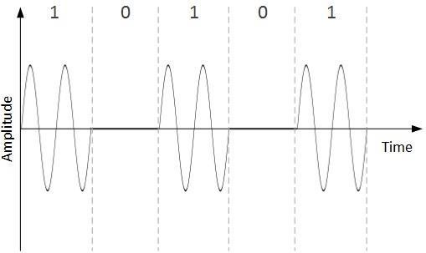

Frequency Shift Keying
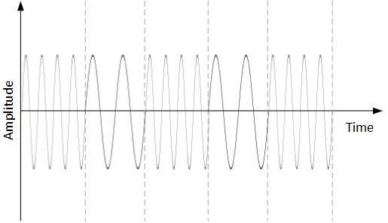
In this conversion technique, the frequency of the analog carrier signal is modified to reflect binary data.
This technique uses two frequencies, f1 and f2. One of them, for example f1, is chosen to represent binary digit 1 and the other one is used to represent binary digit
0. Both amplitude and phase of the carrier wave are kept intact.

Phase Shift Keying
In this conversion scheme, the phase of the original carrier signal is altered to reflect the binary data.
When a new binary symbol is encountered, the phase of the signal is altered. Amplitude and frequency of the original carrier signal is kept intact.
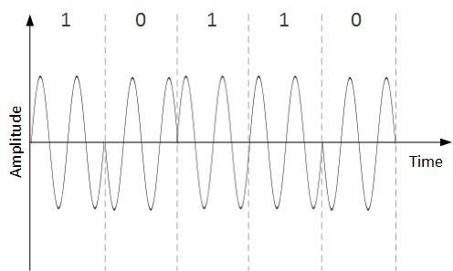

Analog-to-Analog Conversion
Analog signals are modified to represent analog data. This conversion is also known as Analog Modulation. Analog modulation is required when band pass is
used. Analog to analog conversion can be done in three ways:
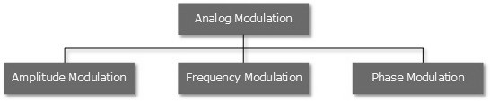

Amplitude Modulation
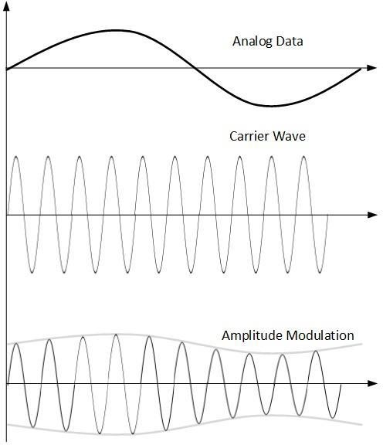
In this modulation, the amplitude of the carrier signal is modified to reflect the analog data.

Amplitude modulation is implemented by means of a multiplier. The amplitude of modulating signal (analog data) is multiplied by the amplitude of carrier frequency, which then reflects analog data.
The frequency and phase of carrier signal remain unchanged.

Frequency Modulation
In this modulation technique, the frequency of the carrier signal is modified to reflect the change in the voltage levels of the modulating signal (analog data).
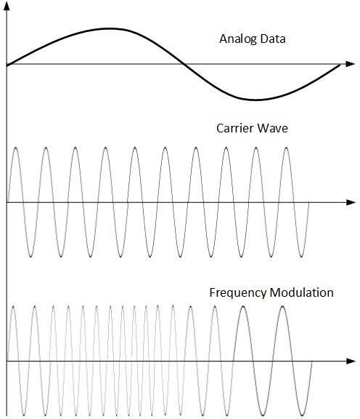
The amplitude and phase of the carrier signal are not altered.

Phase Modulation
In the modulation technique, the phase of carrier signal is modulated in order to reflect the change in voltage (amplitude) of analog data signal.
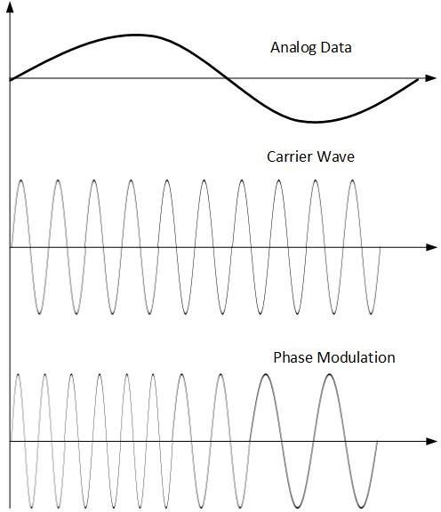
Phase modulation is practically similar to Frequency Modulation, but in Phase modulation frequency of the carrier signal is not increased. Frequency of carrier is signal is changed (made dense and sparse) to reflect voltage change in the amplitude of modulating signal.

CHAPTER 4
- MULTIPLEXING
Multiplexing is a technique by which different analog and digital streams of transmission can be simultaneously processed over a shared link. Multiplexing divides the high capacity medium into low capacity logical medium which is then shared by different streams.
Communication is possible over the air (radio frequency), using a physical media (cable), and light (optical fiber). All mediums are capable of multiplexing.
When multiple senders try to send over a single medium, a device called Multiplexer divides the physical channel and allocates one to each. On the other end of communication, a De-multiplexer receives data from a single medium, identifies each, and sends to different receivers.

Frequency Division Multiplexing
When the carrier is frequency, FDM is used. FDM is an analog technology. FDM divides the spectrum or carrier bandwidth in logical channels and allocates one user to each channel. Each user can use the channel frequency independently and has exclusive access of it. All channels are divided in such a way that they do not overlap with each other. Channels are separated by guard bands. Guard band is a
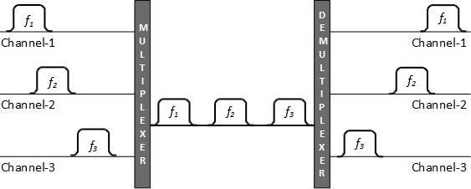
frequency which is not used by either channel.

Time Division Multiplexing
TDM is applied primarily on digital signals but can be applied on analog signals as well. In TDM the shared channel is divided among its user by means of time slot. Each user can transmit data within the provided time slot only. Digital signals are divided in frames, equivalent to time slot i.e. frame of an optimal size which can be transmitted in given time slot. TDM works in synchronized mode. Both ends, i.e. Multiplexer and De-multiplexer are timely synchronized, and both switch to next channel simultaneously.
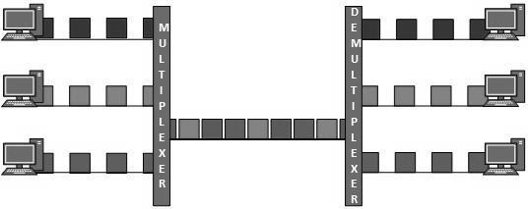
When channel A transmits its frame at one end, the De-multiplexer provides media to channel A on the other end. As soon as the channel A’s time slot expires, this side switches to channel B. On the other end, the De-multiplexer works in a synchronized manner and provides media to channel B. Signals from different channels travel the path in interleaved manner.

Wavelength Division Multiplexing
Light has different wavelength (colors). In fiber optic mode, multiple optical carrier signals are multiplexed into an optical fiber by using different wavelengths. This is an analog multiplexing technique and is done conceptually in the same manner as FDM but uses light as signals.
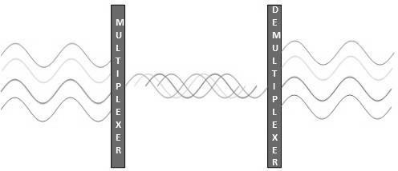

CHAPTER 5

- TRANSMISSION MEDIA
The transmission media is nothing but the physical media over which communication takes place in computer networks.

Magnetic Media
One of the most convenient ways to transfer data from one computer to another, even before the birth of networking, was to save it on some storage media and transfer physical from one station to another. Though it may seem old-fashion way in today’s world of high speed internet, but when the size of data is huge, the magnetic media comes into play.
For example, a bank has to handle and transfer huge data of its customer, which stores a backup of it at some geographically far-away place for security reasons and to keep it from uncertain calamities. If the bank needs to store its huge backup data, then its transfer through internet is not feasible. The WAN links may not support such high speed. Even if they do; the cost is too high to afford. In these cases, data backup is stored onto magnetic tapes or magnetic discs, and then shifted physically at remote places.

Twisted Pair Cable
A twisted pair cable is made of two plastic insulated copper wires twisted together to form a single media. Out of these two wires, only one carries actual signal and another is used for ground reference. The twists between wires are helpful in reducing noise (electro-magnetic interference) and crosstalk.
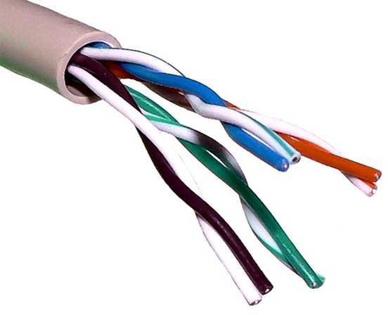

There are two types of twisted pair cables:
    - Shielded Twisted Pair (STP) Cable
    - Unshielded Twisted Pair (UTP) Cable
STP cables comes with twisted wire pair covered in metal foil. This makes it more indifferent to noise and crosstalk.
UTP has seven categories, each suitable for specific use. In computer networks, Cat-5, Cat-5e, and Cat-6 cables are mostly used. UTP cables are connected by RJ45 connectors.

Coaxial Cable
Coaxial cable has two wires of copper. The core wire lies in the center and it is made of solid conductor. The core is enclosed in an insulating sheath. The second wire is wrapped around over the sheath and that too in turn encased by insulator sheath. This all is covered by plastic cover.
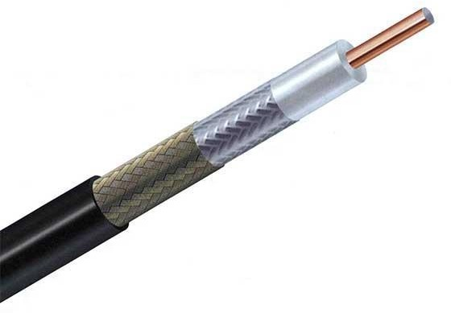
Because of its structure, the coax cable is capable of carrying high frequency signals than that of twisted pair cable. The wrapped structure provides it a good shield against noise and cross talk. Coaxial cables provide high bandwidth rates of up to 450 mbps.
There are three categories of coax cables namely, RG-59 (Cable TV), RG-58 (Thin Ethernet), and RG-11 (Thick Ethernet). RG stands for Radio Government.
Cables are connected using BNC connector and BNC-T. BNC terminator is used to terminate the wire at the far ends.

Power Lines
Power Line communication (PLC) is Layer-1 (Physical Layer) technology which uses power cables to transmit data signals. In PLC, modulated data is sent over the cables. The receiver on the other end de-modulates and interprets the data.
Because power lines are widely deployed, PLC can make all powered devices controlled and monitored. PLC works in half-duplex.
There are two types of PLCs:
    - Narrow band PLC
    - Broad band PLC
Narrow band PLC provides lower data rates up to 100s of kbps, as they work at lower frequencies (3-5000 kHz). They can be spread over several kilometers.
Broadband PLC provides higher data rates up to 100s of Mbps and works at higher frequencies (1.8 – 250 MHz). They cannot be as much extended as Narrowband PLC.

Fiber Optics
Fiber Optic works on the properties of light. When light ray hits at critical angle, it tends to refracts at 90 degree. This property has been used in fiber optic. The core of fiber optic cable is made of high quality glass or plastic. From one end of it light is emitted, it travels through it and at the other end light detector detects light stream and converts it to electric data.
Fiber Optic provides the highest mode of speed. It comes in two modes, one is single mode fiber and second is multimode fiber. Single mode fiber can carry a single ray of light whereas multimode is capable of carrying multiple beams of light.
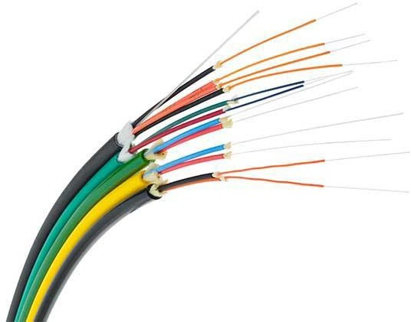
Fiber Optic also comes in unidirectional and bidirectional capabilities. To connect and access fiber optic special type of connectors are used. These can be Subscriber Channel (SC), Straight Tip (ST), or MT-RJ.

WIRELESS TRANSMISSION
Wireless transmission is a form of unguided media. Wireless communication involves no physical link established between two or more devices, communicating wirelessly. Wireless signals are spread over in the air and are received and interpreted by appropriate antennas.
When an antenna is attached to electrical circuit of a computer or wireless device, it converts the digital data into wireless signals and spread all over within its frequency range. The receptor on the other end receives these signals and converts them back to digital data.
A little part of electromagnetic spectrum can be used for wireless transmission.
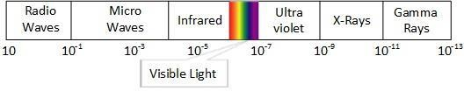

Radio Transmission
Radio frequency is easier to generate and because of its large wavelength it can penetrate through walls and structures alike. Radio waves can have wavelength from 1mm – 100,000km and have frequency ranging from 3Hz (Extremely Low Frequency) to 300 GHz (Extremely High Frequency). Radio frequencies are sub- divided into six bands.
Radio waves at lower frequencies can travel through walls whereas higher RF can travel in straight line and bounce back. The power of low frequency waves decreases sharply as they cover long distance. High frequency radio waves have more power.
Lower frequencies such as VLF, LF, MF bands can travel on the ground up to 1000 kilometers, over the earth’s surface.
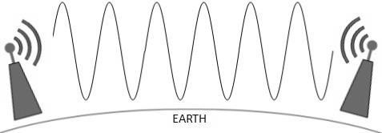

Radio waves of high frequencies are prone to be absorbed by rain and other obstacles. They use Ionosphere of earth atmosphere. High frequency radio waves such as HF and VHF bands are spread upwards. When they reach Ionosphere, they are refracted back to the earth.
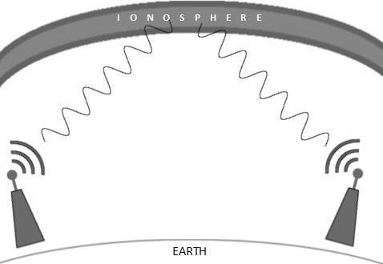

Microwave Transmission
Electromagnetic waves above 100MHz tend to travel in a straight line and signals over them can be sent by beaming those waves towards one particular station. Because Microwaves travels in straight lines, both sender and receiver must be aligned to be strictly in line-of-sight.
Microwaves can have wavelength ranging from 1mm – 1meter and frequency ranging from 300MHz to 300GHz.

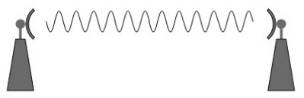
Microwave antennas concentrate the waves making a beam of it. As shown in picture above, multiple antennas can be aligned to reach farther. Microwaves have higher frequencies and do not penetrate wall like obstacles.
Microwave transmission depends highly upon the weather conditions and the frequency it is using.

Infrared Transmission
Infrared wave lies in between visible light spectrum and microwaves. It has wavelength of 700nm to 1mm and frequency ranges from 300GHz to 430THz.
Infrared wave is used for very short range communication purposes such as television and its remote. Infrared travels in a straight line hence it is directional by nature. Because of high frequency range, Infrared cannot cross wall-like obstacles.

Light Transmission
Highest most electromagnetic spectrum which can be used for data transmission is light or optical signaling. This is achieved by means of LASER.
Because of frequency light uses, it tends to travel strictly in straight line. Hence the sender and receiver must be in the line-of-sight. Because laser transmission is unidirectional, at both ends of communication the laser and the photo-detector needs to be installed. Laser beam is generally 1mm wide hence it is a work of precision to align two far receptors each pointing to lasers source.

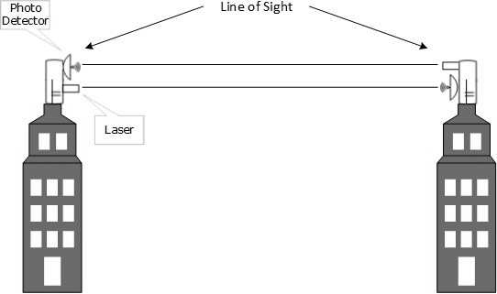

Laser works as Tx (transmitter) and photo-detectors works as Rx (receiver). Lasers cannot penetrate obstacles such as walls, rain, and thick fog. Additionally, laser beam is distorted by wind, atmosphere temperature, or variation in temperature in the path.
Laser is safe for data transmission as it is very difficult to tap 1mm wide laser without interrupting the communication channel.

CHAPTER 6
- Error Detection and Correction
There are many reasons such as noise, cross-talk etc., which may help data to get corrupted during transmission. The upper layers work on some generalized view of network architecture and are not aware of actual hardware data processing. Hence, the upper layers expect error-free transmission between the systems. Most of the applications would not function expectedly if they receive erroneous data. Applications such as voice and video may not be that affected and with some errors they may still function well.
Data-link layer uses some error control mechanism to ensure that frames (data bit streams) are transmitted with certain level of accuracy. But to understand how errors is controlled, it is essential to know what types of errors may occur.

Types of Errors
There may be three types of errors:

Single bit error
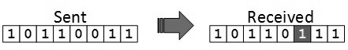
In a frame, there is only one bit, anywhere though, which is corrupt.

Multiple bits error
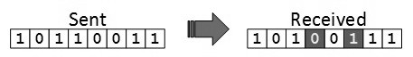
Frame is received with more than one bits in corrupted state.

Burst error
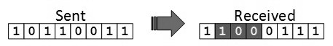
Frame contains more than1 consecutive bits corrupted.
Error control mechanism may involve two possible ways:
      - Error detection
      - Error correction

Error Detection
Errors in the received frames are detected by means of Parity Check and Cyclic Redundancy Check (CRC). In both cases, few extra bits are sent along with actual data to confirm that bits received at other end are same as they were sent. If the counter-check at receiver end fails, the bits are considered corrupted.

Parity Check
One extra bit is sent along with the original bits to make number of 1s either even in case of even parity, or odd in case of odd parity.
The sender while creating a frame counts the number of 1s in it. For example, if even parity is used and number of 1s is even then one bit with value 0 is added. This way number of 1s remains even. If the number of 1s is odd, to make it even a bit with value is added.

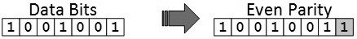

The receiver simply counts the number of 1s in a frame. If the count of 1s is even and even parity is used, the frame is considered to be not-corrupted and is accepted. If the count of 1s is odd and odd parity is used, the frame is still not corrupted.
If a single bit flips in transit, the receiver can detect it by counting the number of 1s. But when more than one bit is erroneous, then it is very hard for the receiver to detect the error.

Cyclic Redundancy Check (CRC)
CRC is a different approach to detect if the received frame contains valid data. This technique involves binary division of the data bits being sent. The divisor is generated using polynomials. The sender performs a division operation on the bits being sent and calculates the remainder. Before sending the actual bits, the sender adds the remainder at the end of the actual bits. Actual data bits plus the remainder is called a codeword. The sender transmits data bits as codeword.
At the other end, the receiver performs division operation on codewords using the same CRC divisor. If the remainder contains all zeros the data bits are accepted, otherwise it is considered as there is some data corruption occurred in transit.

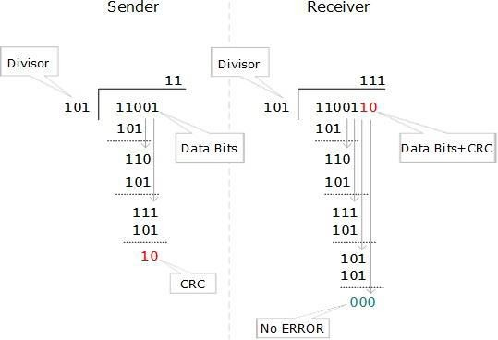

Error Correction
In the digital world, error correction can be done in two ways:

Backward Error Correction
When the receiver detects an error in the data received, it requests back the sender to retransmit the data unit.

Forward Error Correction
When the receiver detects some error in the data received, it executes error- correcting code, which helps it to auto-recover and to correct some kinds of errors. The first one, Backward Error Correction, is simple and can only be efficiently used where retransmitting is not expensive. For example, fiber optics. But in case of wireless transmission retransmitting may cost too much. In the latter case, Forward Error Correction is used.
To correct the error in data frame, the receiver must know exactly which bit in the frame is corrupted. To locate the bit in error, redundant bits are used as parity bits for error detection. For example, we take ASCII words (7 bits data), then there could be 8 kind of information we need: first seven bits to tell us which bit is in error and one more bit to tell that there is no error.
For m data bits, r redundant bits are used. r bits can provide 2r combinations of information. In m+r bit codeword, there is possibility that the r bits themselves may get corrupted. So the number of r bits used must inform about m+r bit locations plus no-error information, i.e. m+r+1.

